**Winter Training Report**

**On**

**Title of project**

**02 – 22 Jan 2024**

**Submitted By:**

**ARYAM (211392)**

**Jaypee University of Information Technology, Solan**



**Under the Guidance of**

**Dr. Mrityunjay Singh**

**Assistant Professor**

**Indian Institute of Information Technology Una**

**Saloh, Himachal Pradesh**

**ACKNOWLEDGMENT**

The Industrial training opportunity from IIIT UNA was a great learning opportunity and a great chance for my personal and professional development. I will try to use the Skills and knowledge I gained during my training in the best possible way. I perceive this opportunity as a big milestone in my career development. I’m grateful to my mentor Dr. Mrityunjay Singh for his support and guidance during the whole Internship Duration and for his support in completion of my project.

**ABOUT THE INSTITUTE**

Indian Institute of Information Technology Una (IIIT, Una) is one of the [Indian Institutes of Information Technology](https://en.wikipedia.org/wiki/Indian_Institutes_of_Information_Technology) located at Vill. Saloh, Teh. Haroli, Distt. Una Himachal Pradesh-177209, [Himachal Pradesh](https://en.wikipedia.org/wiki/Himachal_Pradesh). It is one of the 20 IIITs being set up, funded, and managed by the Ministry of Human Resource Development, Govt. of India under the Public Private Partnership (PPP) model. Established in 2014, it was recognized as an [Institute of National Importance](https://en.wikipedia.org/wiki/Institute_of_National_Importance). IIIT Una is a joint venture of the Ministry of Human Resource Development, Government of India, the Govt. of [Himachal Pradesh](https://en.wikipedia.org/wiki/Himachal_Pradesh), with Industries in Public-Private Partnership model.

**ABSTRACT**

This abstract introduces a bi-directional Long Short-Term Memory (LSTM) model for landslide detection, recognizing the need for an effective algorithm in leveraging the potential of machine learning in this context. Landslides, as natural disasters, can inflict substantial damage and disturbances in affected areas. Early detection is crucial for minimizing their impact, necessitating the development of accurate and efficient models.

The study focuses on Mawiongrim, Meghalaya, India, an active landslide zone. The proposed bi-directional LSTM model utilizes temporal patterns from input data collected by a long-term real-time monitoring system in the area. Assessment of the model's effectiveness involves training it on a dataset comprising various landslide-related characteristics, such as topography, rainfall, hydrological factors, and soil properties.

Results demonstrate that the suggested model excels in detecting landslides with heightened accuracy and minimal error compared to alternative models. Additionally, the model functions as a real-time warning system, proving to be a valuable tool for early landslide detection. The research also underscores the significance of prediction models for matric suction and groundwater level, crucial factors in determining slope stability.

1. **INTRODUCTION:**

In regions susceptible to landslides, such as Mawiongrim, Meghalaya, India, the combination of delicate slopes and persistent rainfall presents a significant risk. When rainfall exacerbates existing instability, slopes can collapse if the soil stress exceeds its shear strength. Predicting landslide occurrences accurately is challenging without understanding their response to climatic events. Monitoring slope movement alone is insufficient; environmental and geotechnical factors play crucial roles. By analysing a comprehensive dataset showcasing slope behaviour under rainwater infiltration, physical and empirical-based models can simulate reliable warning systems.

Seepage, deformation, and other factors influence slope stability, necessitating continuous monitoring. Real-time monitoring using various devices like inclinometers, GPS, and piezometers can provide alerts on potential slope failures. Over the past 50 years, numerous studies have explored landslide prediction using artificial intelligence (AI) and machine learning (ML) models. Advanced techniques like recurrent neural networks (RNNs), residual neural networks, and sampling-based models have shown promise. These models leverage real-time data to predict landslide progression, crucial for anticipating slope failures.

The Long Short-Term Memory (LSTM) model, a type of RNN, has gained traction for its ability to handle long-term dependencies in data. Researchers have enhanced LSTM's performance, demonstrating its effectiveness in various applications, including landslide prediction. By leveraging real-time data from monitoring systems, LSTM models can accurately predict slope movement. Previous studies have shown LSTM's superiority over traditional techniques in terms of robustness and performance.

In machine learning literature, LSTM models have been extensively used for soil movement prediction. These models utilize historical data to forecast potential slope movements, crucial for landslide risk assessment. To address the challenge of predicting soil movements during actual landslides, bidirectional-stacked LSTM ensemble models have been proposed. These models analyse various factors, including rainfall patterns, matric suction, and groundwater levels, to predict slope displacements accurately.

Despite previous research achieving high accuracy levels, prediction models may still have significant errors, particularly when forecasting landslip occurrences. This study aims to develop a prediction model for rainfall-induced landslides using the LSTM method, chosen for its ability to handle long-term data dependencies. The dataset comprises real-time slope monitoring data from Mawiongrim, Meghalaya, India, enabling the analysis of slope displacement dependencies on rainfall patterns, matric suction, and groundwater levels during monsoon periods.

The proposed deep learning model predicts slope inclinations, matric suction, and water levels, critical factors in landslide risk assessment. Compared to existing studies, the models developed in this research exhibit lower error rates and higher accuracy. Five slope inclination models and three models each for matric suction and water level have been developed, providing valuable insights into landslide susceptibility in the study area.

This project aims to contribute to the advancement of landslide prediction methodologies, particularly in regions prone to frequent landslides. By leveraging advanced machine learning techniques and real-time monitoring data, the proposed framework seeks to enhance the accuracy and reliability of landslide prediction systems, ultimately aiding in disaster mitigation efforts.

1. **LITERATURE REVIEW:**

The following table shows the information about various studies done on Landslide.

Table 1: Existing literature on Landslide Prediction

| **Ref. No.** | **Authors** | **Title** | **Journal** | **Year** | **Model Used** |
| --- | --- | --- | --- | --- | --- |
| 1 | M.-G. Angeli, et al. | A critical review of landslide monitoring experiences | Engineering Geology | 2000 | Not specified |
| 2 | R. Greco, et al. | Soil water content and suction monitoring in model slopes for shallow flowslides early warning applications | Physics and Chemistry of the Earth | 2010 | Not specified |
| 3 | H. Rahardjo, et al. | Comprehensive instrumentation for real time monitoring of flux boundary conditions in slope | Procedia Earth and Planetary Science | 2014 | Not specified |
| 4 | K. Das, et al. | Real-time threshold-based landslide prediction system for hilly region using wireless sensor networks | 2020 IEEE International Conference on Consumer Electronics-Taiwan (ICCE-Taiwan) | 2020 | Not specified |
| 5 | S. Li, et al. | Distributed recurrent neural networks for cooperative control of manipulators: A game-theoretic perspective | IEEE transactions on neural networks and learning systems | 2016 | Recurrent Neural Network |
| 6 | L. Jin, et al. | Neural dynamics for distributed collaborative control of manipulators with time delays | IEEE/CAA Journal of Automatica Sinica | 2022 | Recurrent Neural Network |
| 7 | W. Yang, et al. | Highly-accurate manipulator calibration via extended kalman filter-incorporated residual neural network | IEEE Transactions on Industrial Informatics | 2023 | Residual Neural Network |
| 8 | X. Luo, et al. | An alternating-direction-method of multipliers-incorporated approach to symmetric non-negative latent factor analysis | IEEE Transactions on Neural Networks and Learning Systems | 2021 | Symmetric Non-negative Latent Factor Analysis |
| 9 | H. Salehi, et al. | Data mining methodology employing artificial intelligence and a probabilistic approach for energy-efficient structural health monitoring with noisy and delayed signals | Expert Systems with Applications | 2019 | Artificial Neural Network |
| 10 | D. Wu, et al. | A prediction-sampling-based multilayer-structured latent factor model for accurate representation to high-dimensional and sparse data | IEEE Transactions on Neural Networks and Learning Systems | 2022 | Latent Factor Model |
| 11 | F. Huang, et al. | Landslide displacement prediction based on multivariate chaotic model and extreme learning machine | Engineering Geology | 2017 | Extreme Learning Machine |
| 12 | A. Graves, et al. | Bidirectional lstm networks for improved phoneme classification and recognition | Artificial Neural Networks: Formal Models and Their Applications–ICANN 2005: 15th International Conference | 2005 | Bidirectional LSTM |
| 13 | K. Greff, et al. | Lstm: A search space odyssey | IEEE transactions on neural networks and learning systems | 2016 | LSTM |
| 14 | Y. Xing, et al. | Dynamic displacement forecasting of dashuitian landslide in china using variational mode decomposition and stack long short-term memory network | Applied Sciences | 2019 | LSTM |
| 15 | B. Yang, et al. | Time series analysis and long short-term memory neural network to predict landslide displacement | Landslides | 2019 | LSTM |
| 16 | H. Li, et al. | Prediction of landslide displacement with an ensemble-based extreme learning machine and copula models | Landslides | 2018 | Extreme Learning Machine |
| 17 | C. Lian, et al. | Constructing prediction intervals for landslide displacement using bootstrapping random vector functional link networks selective ensemble with neural networks switched | Neurocomputing | 2018 | Neural Network Ensemble |
| 18 | K. Zhang, et al. | Displacement prediction of step-like landslides based on feature optimization and vmd-bi-lstm: a case study of the bazimen and baishuihe landslides in the three gorges, china | Bulletin of Engineering Geology and the Environment | 2021 | Bi-LSTM |
| 19 | P. Kumar, et al. | Bs-lstm: an ensemble recurrent approach to forecasting soil movements in the real world | Frontiers in Earth Science | 2021 | Bi-LSTM Ensemble |
| 20 | F. A. Gers, et al. | Learning to forget: Continual prediction with lstm | Neural Computation | 2000 | LSTM |
| 21 | Q. Meng, et al. | Displacement prediction of water-induced landslides using a recurrent deep learning model | European Journal of Environmental and Civil Engineering | 2020 | Recurrent Deep Learning Model |
| 22 | X. Li, et al. | Landslide displacement prediction based on combining method with optimal weight | Natural Hazards | 2012 | Weighted Combination |
| 23 | C. Zhou, et al. | Application of time series analysis and pso–svm model in predicting the bazimen landslide in the three gorges reservoir, china | Engineering Geology | 2016 | PSO-SVM |
| 24 | C. Lian, et al. | Landslide displacement prediction with uncertainty based on neural networks with random hidden weights | IEEE transactions on neural networks and learning systems | 2016 | Neural Network |
| 25 | Y.-T. Tsai, et al. | Air pollution forecasting using rnn with lstm | 2018 IEEE 16th Intl Conf on Dependable, Autonomic and Secure Computing, 16th Intl Conf on Pervasive Intelligence and Computing, 4th Intl Conf on Big Data Intelligence and Computing and Cyber Science and Technology Congress (DASC/PiCom/DataCom/CyberSciTech) | 2018 | LSTM |
| 26 | P. Xie, et al. | The application of long short-term memory (lstm) method on displacement prediction of multifactor-induced landslides | IEEE Access | 2019 | LSTM |
| 27 | M. K. Nammous, et al. | Using a small amount of text-independent speech data for a bilstm large-scale speaker identification approach | Journal of King Saud University-Computer and Information Sciences | 2022 | Bi-LSTM |
| 28 | E. Brand | Some thoughts on rain-induced slope failures | Proc. 10th ICSMFE | 1981 | Not specified |
| 29 | A. Graves | Generating sequences with recurrent neural networks | arXiv preprint arXiv:1308.0850 | 2013 | Recurrent Neural Network |
| 30 | M. Boden | A guide to recurrent neural networks and backpropagation | The Dallas project | 2002 | Recurrent Neural Network |
| 31 | V. D. Pham, et al. | Convolutional neural network—optimized moth flame algorithm for shallow landslide susceptible analysis | IEEE Access | 2020 | Convolutional Neural Network |
| 32 | H. Pei, et al. | Landslide displacement prediction based on a novel hybrid model and convolutional neural network considering time-varying factors | Bulletin of Engineering Geology and the Environment | 2021 | Hybrid Model, CNN |
| 33 | P. T. T. Ngo, et al. | Evaluation of deep learning algorithms for national scale landslide susceptibility mapping of iran | Geoscience Frontiers | 2021 | Deep Learning Algorithm |
| 34 | D. Tien Bui, et al. | Shallow landslide prediction using a novel hybrid functional machine learning algorithm | Remote Sensing | 2019 | Hybrid Functional Machine Learning Algorithm |
| 35 | B. Thai Pham, et al. | Landslide susceptibility assessment by novel hybrid machine learning algorithms | Sustainability | 2019 | Hybrid Machine Learning Algorithms |
| 36 | H. Wang, et al. | Landslide identification using machine learning | Geoscience Frontiers | 2021 | Machine Learning |
| 37 | M. T. Abraham, et al. | Forecasting landslides using sigma model: a case study from idukki, india | Geomatics, Natural Hazards and Risk | 2021 | Sigma Model |
| 38 | M. Khalili, et al. | Prediction of deformation caused by landslides based on graph convolution networks algorithm and dinsar technique | ISPRS Annals of the Photogrammetry, Remote Sensing and Spatial Information Sciences | 2023 | Graph Convolution Networks, DInSAR |

1. **STUDY AREA:**

The study area, Mawiong Rim in Meghalaya, India, situated along the National Highway 6, Guwahati Shillong (GS) Route, is characterized by its desolate terrain marked by precipitous hillsides, deep valleys, and delicate bedrock. These geographical features significantly increase the susceptibility to landslides in the region. Moreover, the area experiences high rainfall, exacerbating the precarious stability of the mountains. The infrastructure of Mawiong Rim is particularly vulnerable to landslides, posing significant risks to the safety and well-being of the inhabitants.

Due to the natural dangers posed by landslides, which can cause substantial damage and sudden inundation, there is a pressing need for effective land management practices to mitigate the vulnerability to such hazards. This is especially crucial during the monsoon seasons when the risk of landslides is heightened. Implementing appropriate mitigating measures such as early notification systems and relocation strategies is imperative to safeguard the lives and properties of the local residents.

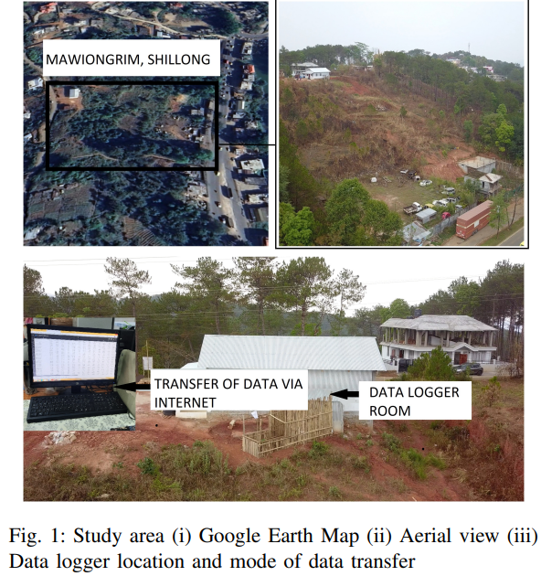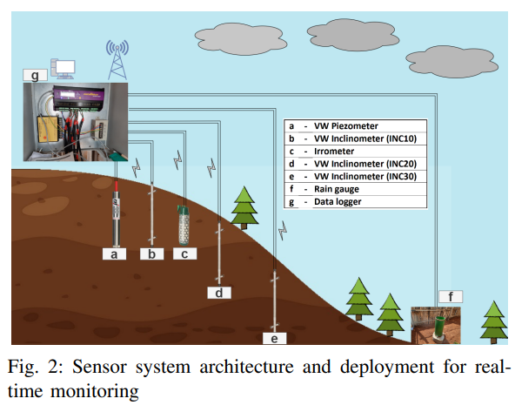

The study underscores the importance of proactive measures to reduce the likelihood and impact of landslides in the Mawiong Rim region, emphasizing the necessity for comprehensive land management strategies and risk reduction efforts.

1. **PROPOSED FRAMEWORK:**

**A. Real-time monitoring system:**

**1.** **Purpose:**

- Focus on incessant heavy rain as the primary cause of landslides.

- Monitoring site: Mawiong Rim on NH-6, GS road, Meghalaya, India.

- Emphasize the importance of understanding slope failure due to rainfall.

**2. Factors Influencing Slope Behaviour:**

- Geotechnical properties, precipitation, vegetation, and hydrological parameters impact slope behaviour.

- Tension fractures during the rainy season facilitate rainwater infiltration.

**3. Extended Monitoring Period:**

- Real-time monitoring system set up for over a year.

- Observing slope behaviour in both dry and wet monsoon seasons.

**4. Sensor Placement and Tracking:**

- Sensors placed around Mawiong Rim to monitor matric suction, groundwater changes, slope displacement, and their response to rain.

**5. Excavation and Borehole Preparation:**

- Site excavation in May 2021 for installing VW piezometer and VW inclinometer.

- VW inclinometer is bidirectional (A+ A- and B+ B-) for readings along SE and SW directions.

**6. Horizontal Displacement Measurement:**

- Three bi-directional VW vertical multi-point inclinometers used for measuring horizontal displacements at various borehole points (10 m, 20 m, and 30 m).

**7. Pressure Sensor (VW Piezometer):**

- Monitors groundwater table (GWT) variation based on detected pressure at its top.

**8. Tensiometers for Matric Suction:**

- Used to monitor negative pore water pressure.

- Sensor range: 50 kg/cm3, readings in centibar (10-2/1 kPa), sensor range: 200 centibar.

**9. Watermark Sensors:**

- Three sensors (I1, I2, I3) installed below the ground surface along the slope.

**10. Rain Gauge Monitoring:**

- Monitors rainfall duration and intensity.

**11. Data Logging and Transmission:**

- Data logger with a capacity of 512 MB.

- Macro-size SIM card inserted for internet connection.

- Data gathered and sent to an email account using the internet connection from the SIM card.

**B. Bi-directional LSTM**

The Bi-directional Long Short-Term Memory (LSTM) model is a key component of our landslide prediction framework. It leverages two independent LSTM layers, one processing the input sequence in the forward direction and the other in the reverse direction, to capture temporal dependencies effectively.

Model Architecture

* **Forward and Reverse LSTM Layers**: The forward LSTM layer processes the input sequence from the first-time step to the last, while the reverse LSTM layer operates in the opposite direction, from the last time step back to the first. Each LSTM cell within these layers estimates an output and a new hidden state at each time step based on the input and the previous hidden state.
* **Concatenation**: Outputs from corresponding time steps of both the forward and reverse LSTM layers are concatenated to create a final representation containing data from each time step's past and future contexts. This enables the model to capture dependencies and patterns in both directions.

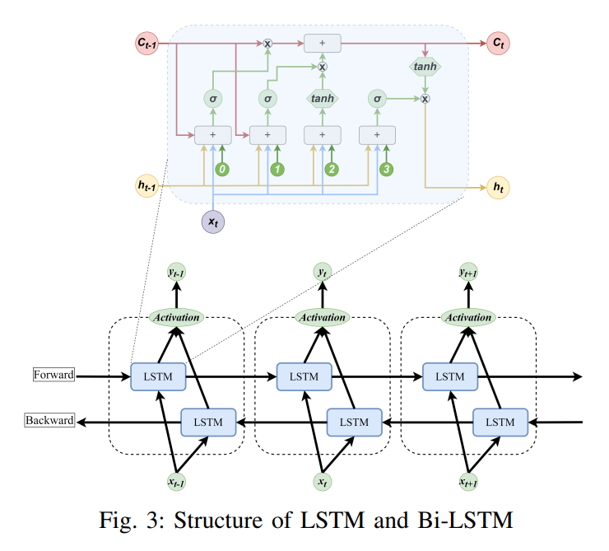

The LSTM layers are governed by the following equations:

1. **Forward LSTM**:
   * *f*, *i*, *o*, *c*: Gate vectors computed using activation functions.
   * *c*: Cell state updated based on forget gate *f*​ and input gate *i*.
   * ℎ∼: Hidden state updated using output gate *o* and cell state *c*.
2. **Reverse LSTM**:
   * Operates similarly to the forward LSTM but processes the input sequence in reverse order.
3. **Bi-directional LSTM Output**:
   * Concatenates outputs from both directions to create a final representation.
   * *ot*​ and *ht*​ are computed using activation functions and previous cell states.
   * *yt*​ is the output sequence.

**Application in Landslide Prediction**

The Bi-directional LSTM model is employed to predict slope deflections along SE and SW directions, soil matric suction, changing groundwater table (GWT), and other relevant parameters contributing to landslide susceptibility. Six models are prepared for slope displacement, three for matric suction, and one for GWT variation.

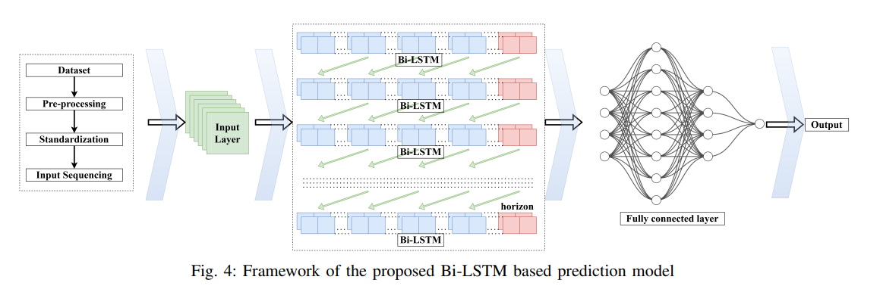

**TABLE2: Parameters of the model for slope displacement and matric suction**

| **Parameter** | **Inclinometer Depth and Orientation** | | | | | |
| --- | --- | --- | --- | --- | --- | --- |
|  | **30m up**  **(INC-30U)** | **30m down**  **(INC-30U)** | **20m up**  **(INC-30U)** | **20m down**  **(INC-30U)** | **10m up**  **(INC-30U)** | **10m down**  **(INC-30U)** |
| Input Unit | 512 | 192 | 512 | 512 | 32 | 96 |
| Number of Layers | 4 | 4 | 4 | 4 | 4 | 4 |
| LSTM 0 units | 512 | 64 | 32 | 32 | 512 | 448 |
| Layer 2 neurons | 512 | 416 | 32 | 512 | 32 | 224 |
| Dropout rate | 0.0 | 0.1 | 0.0 | 0.0 | 0.0 | 0.1 |
| Dense activation | tanh | tanh | ReLU | ReLU | ReLU | ReLU |
| LSTM 1 units | 32 | 32 | 32 | 32 | 32 | 32 |
| LSTM 2 units | 32 | 32 | 32 | 32 | 32 | 32 |
| LSTM 3 units | 32 | 32 | 32 | 32 | 32 | 32 |
| MSE | 0.003188 | 0.005424 | 0.002544 | 0.00617 | 0.001882 | 0.002568 |
| R2 Score | 0.91 | 0.90 | 0.91 | 0.91 | 0.91 | 0.91 |

| **Parameter** | **Matric Suction and Water Level** | | | |
| --- | --- | --- | --- | --- |
|  | **MSI (11)** | **MSI (12)** | **MSI (13)** | **WL** |
| Input Unit | 448 | 320 | 352 | 256 |
| Number of Layers | 4 | 1 | 2 | 1 |
| LSTM 0 units | 416 | 64 | 192 | 352 |
| Layer 2 neurons | 32 | 352 | 288 | 256 |
| Dropout rate | 0.3 | 0.2 | 0.2 | 0.0 |
| Dense activation | tanh | tanh | ReLU | tanh |
| LSTM 1 units | 32 | 128 | 32 | 32 |
| LSTM 2 units | 32 | 32 | 32 | 32 |
| LSTM 3 units | 32 | 32 | 32 | 32 |
| MSE | 0.002302 | 6.68E-06 | 32 | 0.00406 |
| R2 Score | 0.95 | 0.99 | 0.91 | 0.99 |

**Model Evaluation**

The performance of the Bi-directional LSTM models is evaluated using metrics such as Mean Squared Error (MSE) and R-squared (R2) score. Data normalization and a 75%-25% train-test split are performed to ensure robust model evaluation.

**Parameter Tuning**

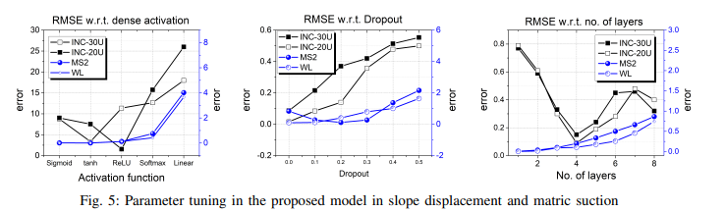

Hyperparameters of the Bi-directional LSTM models, including LSTM units, number of layers, dropout rate, and activation functions, are optimized through parameter tuning to enhance model performance and accuracy in landslide prediction.

By integrating the Bi-directional LSTM model into our framework, we aim to provide accurate and reliable predictions for landslide susceptibility in the study area, enabling proactive measures for disaster mitigation and risk management.

1. **EXPERIMENTAL DESIGN**

In this study the main agenda is to compare various machine learning algorithms on the basis of their performance in predicting the price of cryptocurrencies. For the implementation of the same, the configuration of the system used is as follows- intel(R) Core (TM) i5-8265U CPU @ 1.60GHz 1.80 GHz. The whole implementation for this study is done in the Google Collaboratory. Now, we discuss the evaluated results on the basis of different performance parameters. The python libraries that have been used in this study are:- pandas, numpy, matplotlib, seaborn, scikit learn, stats models.

1. **RESULTS / DISCUSSIONS:**

To check the error of the model, mean square error (MSE), which is the average of the square of the difference between the actual and the predicted values of the variable, is observed. The inaccuracy increases with the increasing numbers. An indicator of how much variation for a dependent variable can be explained by an independent variable is called R-squared (R2). R2 evaluates a model’s goodness of fit. Therefore, a higher R2 value denotes a good fit, whereas a lower R2 denotes a poor fit for the model. The displacements are given by the inclinometers, which are placed below the ground at depths of 10m, 20m and 30m. These inclinometers give two sets of data along SE (southeast) and SW (southwest) directions; therefore, six displacements are obtained. After reading the dataset, only the required input and target variables are filtered. The input variables for predicting slope displacements (INC) are rainfall, water pressure, water level, time and matrix suction. Rainfall and time are used as inputs for the prediction of the Matrix Suction (MS).

**Predictive Models:**

* **Predictive Models and Parameters:** The study employed predictive models to forecast soil movement based on various parameters. These parameters were crucial inputs for the models and played a significant role in predicting soil behavior accurately. The article likely provides detailed information on the selection and significance of these parameters in the context of soil movement prediction.
* **LSTM Layer Configuration:** Long Short-Term Memory (LSTM) networks were a key component of the predictive models. The configuration of LSTM layers, including the number of units defining the dimension of hidden states or outputs, and the number of parameters in each LSTM layer, was carefully considered. Different configurations may have been tested and evaluated to determine the most effective setup for soil movement prediction.
* **Training with Deep Learning Techniques:** The models were trained using deep learning techniques, which involve complex algorithms capable of learning patterns and relationships from large amounts of data. Factors such as the number of layers, units in each layer, dropout rate (a regularization technique to prevent overfitting), activation functions, and batch size were adjusted during training to optimize model performance.
* **Impact of Model Parameters on Performance:** The study likely analysed how variations in model parameters, such as the number of LSTM units, layers, and dropout rates, influenced model performance. Metrics like mean squared error (MSE) and R2 score were used to assess the accuracy and effectiveness of the models. Models with higher LSTM units, more layers, and a higher dropout rate may have shown improved performance in terms of lower MSE and higher R2 score.
* **Activation Functions and Model Outcomes:** The choice of activation function, such as tanh or ReLU, in the dense layer of the model significantly affected the prediction outcomes. The article may discuss how different activation functions impacted the model's ability to capture complex relationships in the data and make accurate predictions.
* **Model Accuracy and Evaluation:** The accuracy of the predictive models was evaluated using both training and testing datasets. Metrics like overall accuracy, R2 score, and root mean squared error (RMSE) were likely used to assess how well the models performed in predicting soil displacement and water levels under various conditions.

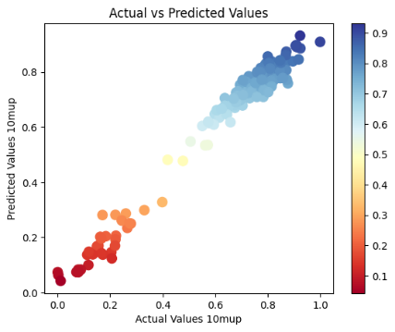 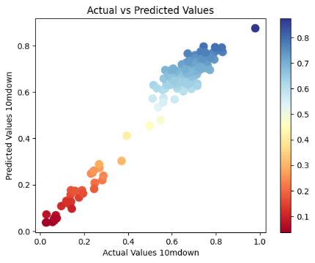 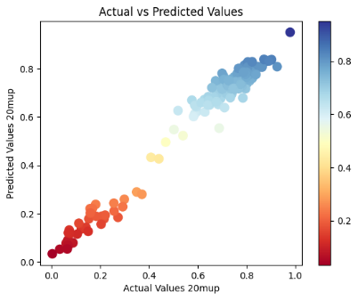

1. (b) (c)

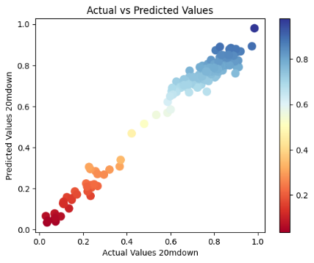 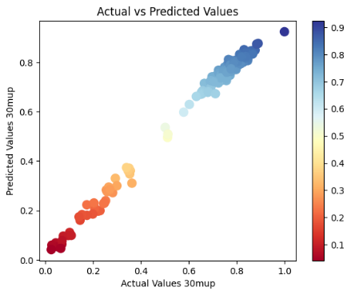 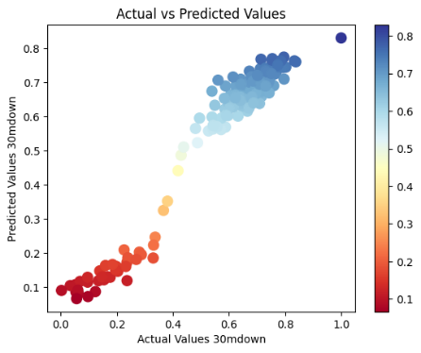

(d) (e) (f)

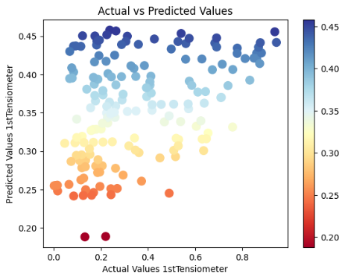 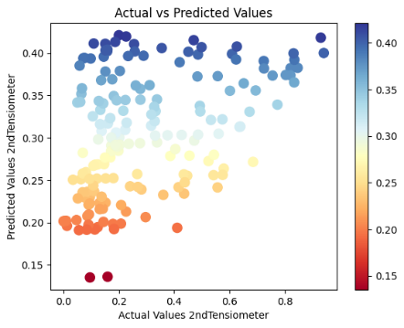 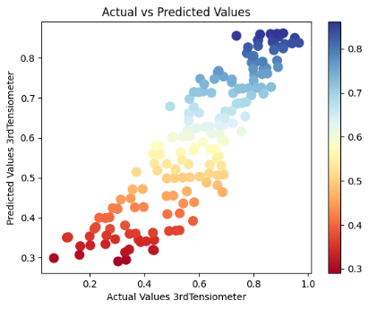

(g) (h) (i)

**Fig. 6: Correlation between actual and predicted values (a) INC-10U, (b) INC-10D, (c) INC-20U, (d) INC-30D, (e) INC-30U, (f) INC-30D, (g) Matric suction 1, (h) Matric suction 2, (i) Matric suction 3**

* **Comparison with Existing Models:** The study compared the performance of the proposed Bi-LSTM model with other existing models used for similar predictions. By evaluating metrics like R2 score and RMSE, the study demonstrated the superiority of the proposed model in accurately predicting soil behaviour.
* **Insights from Matric Suction Models:** The study likely discussed how models predicting matric suction provided valuable insights into soil moisture content. Understanding variations in soil moisture is crucial for making informed decisions regarding water management practices.
* **Seasonal Fluctuations and Groundwater Dynamics:** The models accurately predicted seasonal fluctuations in water levels, indicating the dynamic nature of the groundwater system. This insight is valuable for understanding how groundwater levels respond to changing environmental conditions over time.
* **Optimism about Future Predictions:** Based on the model's predictions and insights gained from the study, there may be optimism about the future behaviour of groundwater levels. This optimism is likely rooted in the model's ability to accurately forecast soil behaviour under various scenarios, providing valuable information for planning and decision-making.

**TABLE III: Comparison between the previous model and the proposed work for predicting slope displacement and matric suction.**

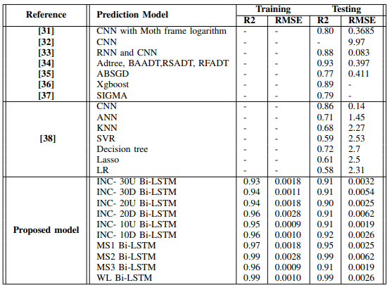

**Comparative Analysis:**

**TABLE III: Comparison of the proposed model with LSTM and Bi-LSTM models in the landslide dataset**

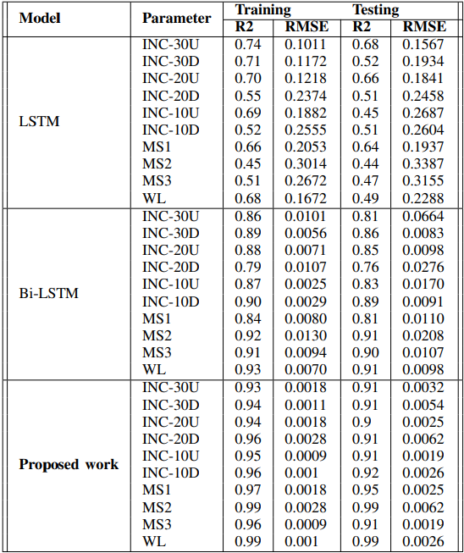

The metrics in Table IV show a comparison of the proposed model with its predecessor LSTM and Bi-LSTM models implemented on the same dataset. The auto-regressive component of the model incorporates its previous predictions as inputs for making subsequent predictions. This incorporates feedback derived from prior predictions into the modelling procedure. In contrast to LSTM and Bi-LSTM models, which are commonly utilized for univariate sequences, an autoregressive multivariate Bi-LSTM architecture is specifically developed to accommodate multivariate data, wherein each time step can encompass multiple features or variables. This enables the capturing of relationships among multiple factors concurrently. The model can capture the spatial and temporal dependencies of the data. The proposed method utilizes bidirectional context to account for temporal dependencies and incorporates multivariate features to capture spatial relationships. The proposed approach in machine learning is the auto-regressive multivariate Bi-LSTM, designed to produce multiple outputs at each time step. Each of these outputs corresponds to a predicted variable. This characteristic renders it highly suitable for forecasting multivariate time series data. The auto-regressive multivariate Bi-LSTM is a sophisticated model that integrates bidirectional modelling, multivariate feature handling, and auto-regressive feedback to enhance the accuracy of predictions for multivariate temporal data.

1. **CONCLUSION:**

This method uses deep learning and focuses on actively predicting periodic displacement due to local precipitation.

• There is a good agreement between the measured and anticipated deformation values.

• The findings imply that rainfall is the most significant dynamic and numerous elements influencing the deformation of the slope displacement in the Mawiong Rim landslide.

• The bi-directional LSTM model and concept offer a potentially effective means of improving the effectiveness and precision of the landslide warning system on the ground ( [18], [19]). The bi-directional LSTM model can be used to predict the slope displacement, the matric suction, and water level using INC-Model, MS-Model, and WL-Model, respectively.

• An economical tool is developed for predicting soil slope instability at a local scale level. The models developed predict slope displacements, matric suction, and GWL. The models developed did not require soil parameters or geometrical data to accurately predict the GWL, matric suction, and slope displacement. Hence, these models can be easily applied to any other area, knowing the site’s initial water level, matric suction, and rainfall patterns.

• Past research shows that most of them have high accuracy levels but also high root means square errors. Hence, this shows that the prediction models may have high errors while predicting the landslide phenomenon. Therefore, the current study gives highly accurate predictions and shallow errors in predicting landslides or slope displacements.

1. **REFERENCES**

[1] M.-G. Angeli, A. Pasuto, and S. Silvano, "A critical review of landslide monitoring experiences," *Engineering Geology*, vol. 55, no. 3, pp. 133–147, 2000.

[2] R. Greco, A. Guida, E. Damiano, and L. Olivares, "Soil water content and suction monitoring in model slopes for shallow flowslides early warning applications," *Physics and Chemistry of the Earth, Parts A/B/C*, vol. 35, no. 3-5, pp. 127–136, 2010.

[3] H. Rahardjo, A. S. Nio, F. R. Harnas, and E. C. Leong, "Comprehensive instrumentation for real time monitoring of flux boundary conditions in slope," *Procedia Earth and Planetary Science*, vol. 9, pp. 23–43, 2014.

[4] K. Das, S. Majumdar, S. Moulik, and M. Fujita, "Real-time threshold-based landslide prediction system for hilly region using wireless sensor networks," in *2020 IEEE International Conference on Consumer Electronics-Taiwan (ICCE-Taiwan)*. IEEE, 2020, pp. 1–2.

[5] S. Li, J. He, Y. Li, and M. U. Rafique, "Distributed recurrent neural networks for cooperative control of manipulators: A game-theoretic perspective," *IEEE transactions on neural networks and learning systems*, vol. 28, no. 2, pp. 415–426, 2016.

[6] L. Jin, X. Zheng, and X. Luo, "Neural dynamics for distributed collaborative control of manipulators with time delays," *IEEE/CAA Journal of Automatica Sinica*, vol. 9, no. 5, pp. 854–863, 2022.

[7] W. Yang, S. Li, Z. Li, and X. Luo, "Highly-accurate manipulator calibration via extended kalman filter-incorporated residual neural network," *IEEE Transactions on Industrial Informatics*, 2023.

[8] X. Luo, Y. Zhong, Z. Wang, and M. Li, "An alternating-direction-method of multipliers-incorporated approach to symmetric non-negative latent factor analysis," *IEEE Transactions on Neural Networks and Learning Systems*, 2021.

[9] H. Salehi, S. Das, S. Biswas, and R. Burgueno, "Data mining methodology employing artificial intelligence and a probabilistic approach for energy-efficient structural health monitoring with noisy and delayed signals," *Expert Systems with Applications*, vol. 135, pp. 259–272, 2019.

[10] D. Wu, X. Luo, Y. He, and M. Zhou, "A prediction-sampling-based multilayer-structured latent factor model for accurate representation to high-dimensional and sparse data," *IEEE Transactions on Neural Networks and Learning Systems*, 2022.

[11] F. A. Gers, J. Schmidhuber, and F. Cummins, "Learning to forget: Continual prediction with lstm," *Neural computation*, vol. 12, no. 10, pp. 2451–2471, 2000.

[12] Q. Meng, H. Wang, M. He, J. Gu, J. Qi, and L. Yang, "Displacement prediction of water-induced landslides using a recurrent deep learning model," *European Journal of Environmental and Civil Engineering*, pp. 1–15, 2020.

[13] X. Li, J. Kong, and Z. Wang, "Landslide displacement prediction based on combining method with optimal weight," *Natural Hazards*, vol. 61, pp. 635–646, 2012.

[14] C. Zhou, K. Yin, Y. Cao, and B. Ahmed, "Application of time series analysis and pso–svm model in predicting the bazimen landslide in the three gorges reservoir, china," *Engineering geology*, vol. 204, pp. 108–120, 2016.

[15] C. Lian, Z. Zeng, W. Yao, H. Tang, and C. L. P. Chen, "Landslide displacement prediction with uncertainty based on neural networks with random hidden weights," *IEEE transactions on neural networks and learning systems*, vol. 27, no. 12, pp. 2683–2695, 2016.

[16] Y.-T. Tsai, Y.-R. Zeng, and Y.-S. Chang, "Air pollution forecasting using rnn with lstm," in *2018 IEEE

16th Intl Conf on Dependable, Autonomic and Secure Computing, 16th Intl Conf on Pervasive Intelligence and Computing, 4th Intl Conf on Big Data Intelligence and Computing and Cyber Science and Technology Congress (DASC/PiCom/DataCom/CyberSciTech)*. IEEE, 2018, pp. 1074–1079.

[17] P. Xie, A. Zhou, and B. Chai, "The application of long short-term memory (lstm) method on displacement prediction of multifactor-induced landslides," *IEEE Access*, vol. 7, pp. 54,305–54,311, 2019.

[18] M. K. Nammous, K. Saeed, and P. Kobojek, "Using a small amount of text-independent speech data for a bilstm large-scale speaker identification approach," *Journal of King Saud University-Computer and Information Sciences*, vol. 34, no. 3, pp. 764–770, 2022.

[19] E. Brand, "Some thoughts on rain-induced slope failures," in *Proc. 10th ICSMFE*, vol. 3, 1981, pp. 373–376.

[20] A. Graves, "Generating sequences with recurrent neural networks," *arXiv preprint arXiv:1308.0850*, 2013.

[21] M. Boden, "A guide to recurrent neural networks and backpropagation," the Dallas project, vol. 2, no. 2, pp. 1–10, 2002.

[22] V. D. Pham, Q.-H. Nguyen, H.-D. Nguyen, V.-M. Pham, Q.-T. Bui et al., "Convolutional neural network—optimized moth flame algorithm for shallow landslide susceptible analysis," *IEEE Access*, vol. 8, pp. 32,727–32,736, 2020.

[23] H. Pei, F. Meng, and H. Zhu, "Landslide displacement prediction based on a novel hybrid model and convolutional neural network considering time-varying factors," *Bulletin of Engineering Geology and the Environment*, vol. 80, no. 10, pp. 7403–7422, 2021.

[24] P. T. T. Ngo, M. Panahi, K. Khosravi, O. Ghorbanzadeh, N. Kariminejad, A. Cerda, and S. Lee, "Evaluation of deep learning algorithms for national scale landslide susceptibility mapping of iran," *Geoscience Frontiers*, vol. 12, no. 2, pp. 505–519, 2021.

[25] D. Tien Bui, H. Shahabi, E. Omidvar, A. Shirzadi, M. Geertsema, J. J. Clague, K. Khosravi, B. Pradhan, B. T. Pham, K. Chapi et al., "Shallow landslide prediction using a novel hybrid functional machine learning algorithm," *Remote Sensing*, vol. 11, no. 8, p. 931, 2019.

[26] B. Thai Pham, A. Shirzadi, H. Shahabi, E. Omidvar, S. K. Singh, M. Sahana, D. Talebpour Asl, B. Bin Ahmad, N. Kim Quoc, and S. Lee, "Landslide susceptibility assessment by novel hybrid machine learning algorithms," *Sustainability*, vol. 11, no. 16, p. 4386, 2019.

[27] H. Wang, L. Zhang, K. Yin, H. Luo, and J. Li, "Landslide identification using machine learning," *Geoscience Frontiers*, vol. 12, no. 1, pp. 351–364, 2021.

[28] M. T. Abraham, N. Satyam, N. Shreyas, B. Pradhan, S. Segoni, K. N. Abdul Maulud, and A. M. Alamri, "Forecasting landslides using sigma model: a case study from idukki, india," *Geomatics, Natural Hazards and Risk*, vol. 12, no. 1, pp. 540–559, 2021.

[29] M. Khalili, L. Guerriero, M. Pouralizadeh, D. Calcaterra, and D. Di Martire, "Prediction of deformation caused by landslides based on graph convolution networks algorithm and dinsar technique," *ISPRS Annals of the Photogrammetry, Remote Sensing and Spatial Information Sciences*, vol. 10, pp. 391–397, 2023.

[30] M.-G. Angeli, A. Pasuto, and S. Silvano, "A critical review of landslide monitoring experiences," *Engineering Geology*, vol. 55, no. 3, pp. 133–147, 2000.

[31] R. Greco, A. Guida, E. Damiano, and L. Olivares, "Soil water content and suction monitoring in model slopes for shallow flowslides early warning applications," *Physics and Chemistry of the Earth, Parts A/B/C*, vol. 35, no. 3-5, pp. 127–136, 2010.

[32] H. Rahardjo, A. S. Nio, F. R. Harnas, and E. C. Leong, "Comprehensive instrumentation for real time monitoring of flux boundary conditions in slope," *Procedia Earth and Planetary Science*, vol. 9, pp. 23–43, 2014.

[33] K. Das, S. Majumdar, S. Moulik, and M. Fujita, "Real-time threshold-based landslide prediction system for hilly region using wireless sensor networks," in *2020 IEEE International Conference on Consumer Electronics-Taiwan (ICCE-Taiwan)*. IEEE, 2020, pp. 1–2.

[34] S. Li, J. He, Y. Li, and M. U. Rafique, "Distributed recurrent neural networks for cooperative control of manipulators: A game-theoretic perspective," *IEEE transactions on neural networks and learning systems*, vol. 28, no. 2, pp. 415–426, 2016.

[35] L. Jin, X. Zheng, and X. Luo, "Neural dynamics for distributed collaborative control of manipulators with time delays," *IEEE/CAA Journal of Automatica Sinica*, vol. 9, no. 5, pp. 854–863, 2022.

[36] W. Yang, S. Li, Z. Li, and X. Luo, "Highly-accurate manipulator calibration via extended kalman filter-incorporated residual neural network," *IEEE Transactions on Industrial Informatics*, 2023.

[37] X. Luo, Y. Zhong, Z. Wang, and M. Li, "An alternating-direction-method of multipliers-incorporated approach to symmetric non-negative latent factor analysis," *IEEE Transactions on Neural Networks and Learning Systems*, 2021.

[38] H. Salehi, S. Das, S. Biswas, and R. Burgueno, "Data mining methodology employing artificial intelligence and a probabilistic approach for energy-efficient structural health monitoring with noisy and delayed signals," *Expert Systems with Applications*, vol. 135, pp. 259–272, 2019.